NAND2Tetris Hardware Simulator
Implementation of NOT, AND and OR Gates using NAND Gate
Name: VASEEM AKRAM
Course: B.Tech CSE
University: K.R. Mangalam University

1. Aim
To implement NOT, AND and OR logic gates using only NAND gates and verify their functionality using the Nand2Tetris Hardware Simulator.

2. NAND Gate
NAND is a universal logic gate. Its Boolean expression is:
Y = NOT(A · B)
A | B | NAND
0 | 0 | 1
0 | 1 | 1
1 | 0 | 1
1 | 1 | 0

3. NOT Gate using NAND
A NOT gate is implemented by connecting both inputs of a NAND gate to the same input.
Boolean Expression: OUT = A NAND A = NOT A
A | OUT
0 | 1
1 | 0
Not.hdl:
CHIP Not {
IN in;
OUT out;
PARTS:
Nand(a=in, b=in, out=out);
}

4. AND Gate using NAND
First NAND produces X = A NAND B. A second NAND is used as an inverter: OUT = X NAND X = A AND B.
A | B | OUT
0 | 0 | 0
0 | 1 | 0
1 | 0 | 0
1 | 1 | 1
And.hdl:
CHIP And {
IN a, b;
OUT out;
PARTS:
Nand(a=a, b=b, out=x);
Nand(a=x, b=x, out=out);
}

5. OR Gate using NAND
Using De Morgan's law: A OR B = NOT(NOT A AND NOT B). NAND gates are used as inverters for A and B.
A | B | OUT
0 | 0 | 0
0 | 1 | 1
1 | 0 | 1
1 | 1 | 1
Or.hdl:
CHIP Or {
IN a, b;
OUT out;
PARTS:
Nand(a=a, b=a, out=notA);
Nand(a=b, b=b, out=notB);
Nand(a=notA, b=notB, out=out);
}

6. Test Cases
Gate | Number of Tests | Combinations | Expected Outputs
NOT | 2 | 0, 1 | 1, 0
AND | 4 | 00, 01, 10, 11 | 0, 0, 0, 1
OR | 4 | 00, 01, 10, 11 | 0, 1, 1, 1
Total test combinations = 10.

7. Simulation Results
The HDL circuits are tested using the Nand2Tetris Hardware Simulator.
Gate | Tests | Result
NOT | 2 | PASS
AND | 4 | PASS
OR | 4 | PASS
Screenshots of the successful simulator output can be inserted below this section.
NOT Gate Simulator Screenshot
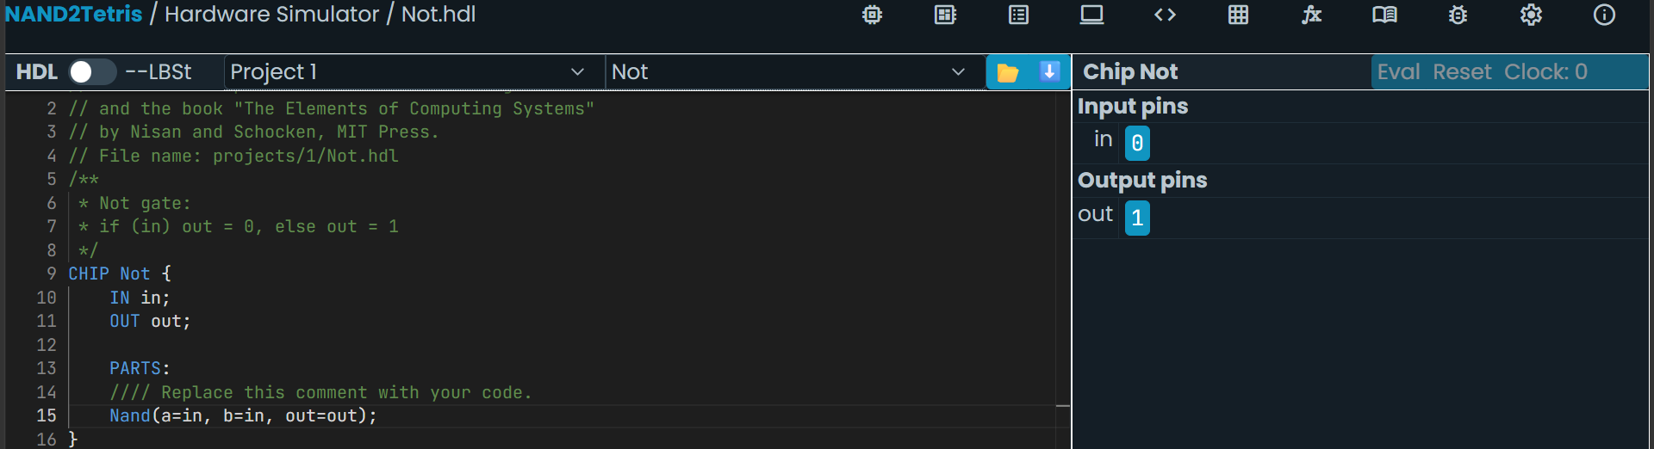
NOT gate simulation: in = 0 → out = 1
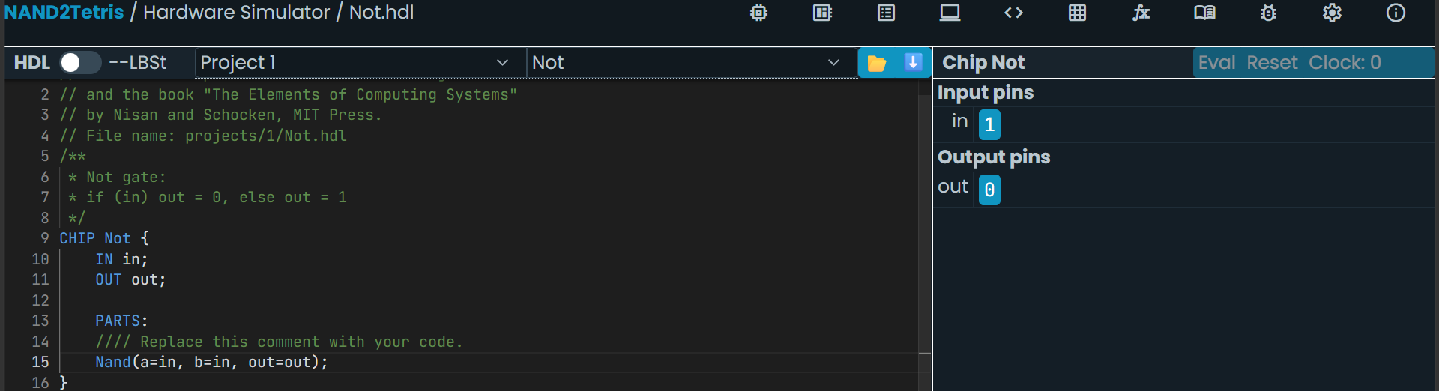
NOT gate simulation: in = 1 → out = 0
AND Gate Simulator Screenshot
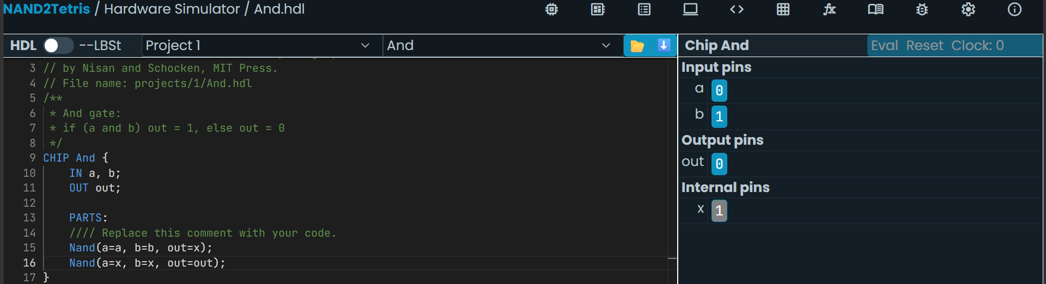
AND gate simulation: a = 0, b = 1 → out = 0
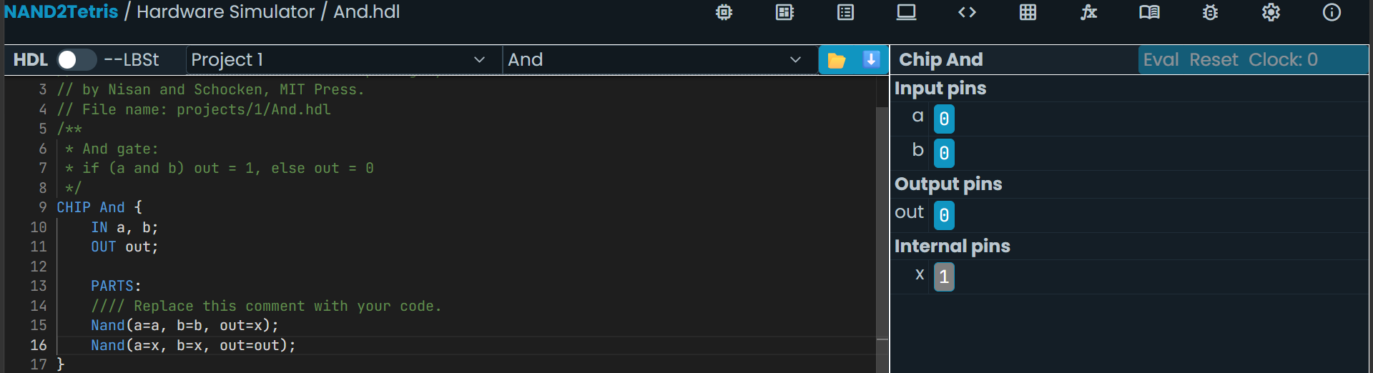
AND gate simulation: a = 0, b = 0 → out = 0
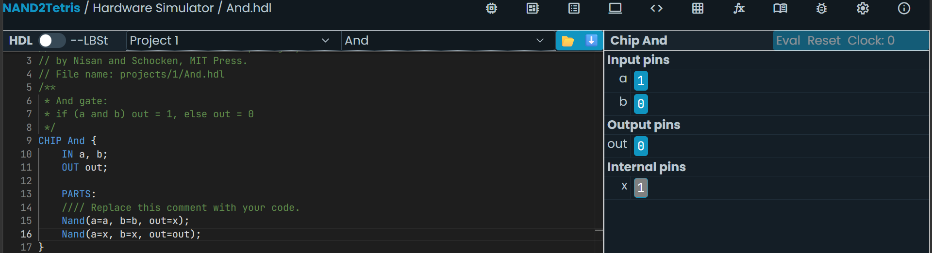
AND gate simulation: a = 1, b = 0 → out = 0
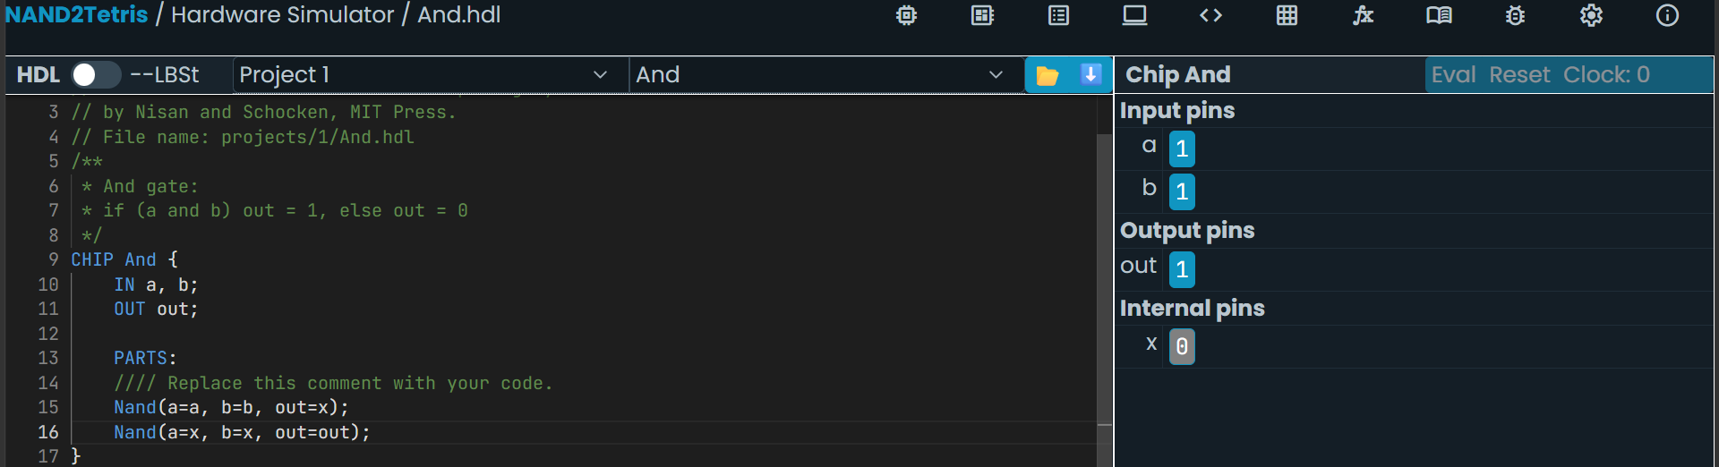
AND gate simulation: a = 1, b = 1 → out = 1
OR Gate Simulator Screenshot
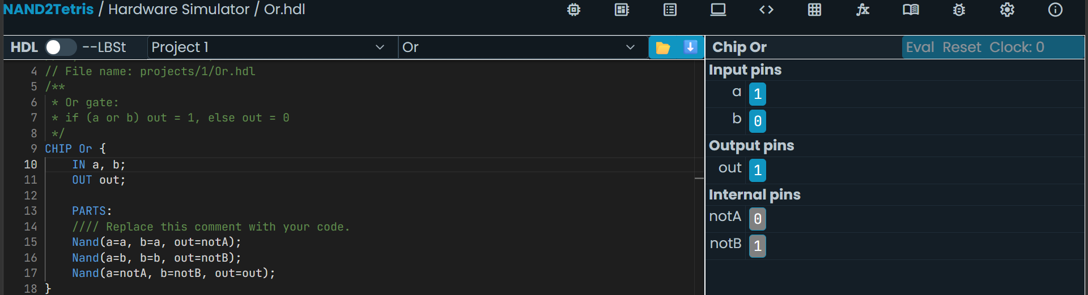
OR gate simulation: a = 1, b = 0 → out = 1
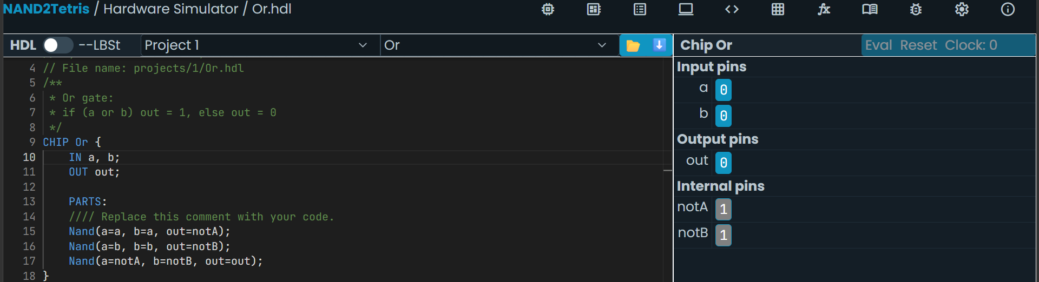
OR gate simulation: a = 0, b = 0 → out = 0

8. GitHub Repository
The HDL and test files should be uploaded to a GitHub repository.
Recommended files: Not.hdl, And.hdl, Or.hdl, Not.tst, And.tst, Or.tst and README.md.
GitHub Repository Link: ______________________________

9. Conclusion
NOT, AND and OR gates were successfully implemented using NAND gates. The outputs were verified using the Nand2Tetris Hardware Simulator. The HDL and test files can be maintained in a GitHub repository.

